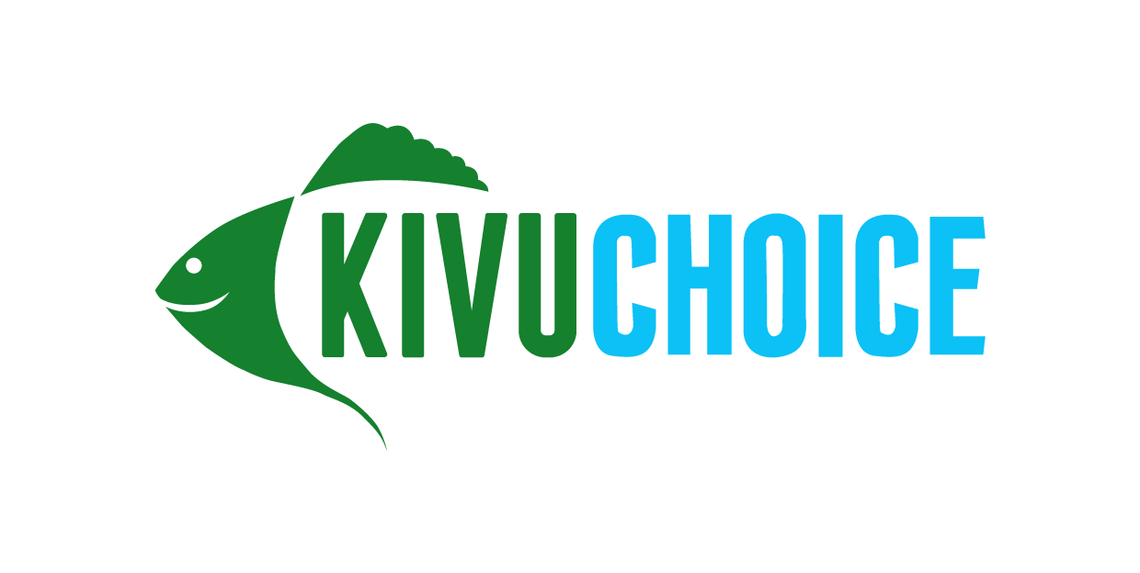

Job Title: Security Officer
Location: Kigembe/Mwaga
Compensation: 150k- 200k NET
Start date: As soon as possible

About Kivu Choice:
Kivu Choice is the sister company to Victory Farms, the largest fish farm in East Africa, based in Kenya. We launched our Rwandan business in late 2021 and have since secured and commenced operations at two farm sites across Rwanda and will be launching our commercial operations in the coming weeks. Over the next 5 years our plan is to scale to become the largest and most sustainable protein producer in the country, producing and distributing over 50 million fish meals per year across Rwanda and DRC.

Description:
Kivu Choice is looking for an aspiring Security Officer to join our team and play an integral role in building the country’s premier aquaculture business. Should you be chosen, you will be trained from the ground up and work side by side with the Security Manager as we build out one of the largest aquaculture operations in Africa.

What we’re looking for:
- The successful candidate is likely to have 3 years of working experience in security or operations with at least a High School level of education.
- Ability to thrive while working collaboratively with colleagues, identifying, and solving problems independently in a fast-paced environment
- A successful candidate will possess a strong work ethic, ability to work in teams, intellectual curiosity, and ability to structure and solve problems
- Must be able to swim in open water
- Fluent in English and Kinyarwanda (Do not apply if you are not fluent in English!)
Duties:
- Conduct inspections on a regular basis to determine need and extent of service on equipment and systems related to safety & security
- Conduct security checks in collaboration with the Security supervisor·
- Record all daily incidences and accidents in the security occurrence book as well as on the adopted platform and submit to superiors for review
- Ensure the security, safety, and well-being of all personnel, visitors, and the premises
- Protect the company's assets relative to theft, assault, fire, and other safety issues
- Secure premises and personnel by patrolling property; monitoring surveillance equipment; inspecting buildings, equipment, and access points; permitting entry
- Report suspicious activity, criminal behavior, and security breaches
- Prevent losses and damage by reporting irregularities, informing violators of policy and procedures, restraining trespassers
To apply, send your CV and the job title you’re applying for to recruiting@kivuchoice.com

