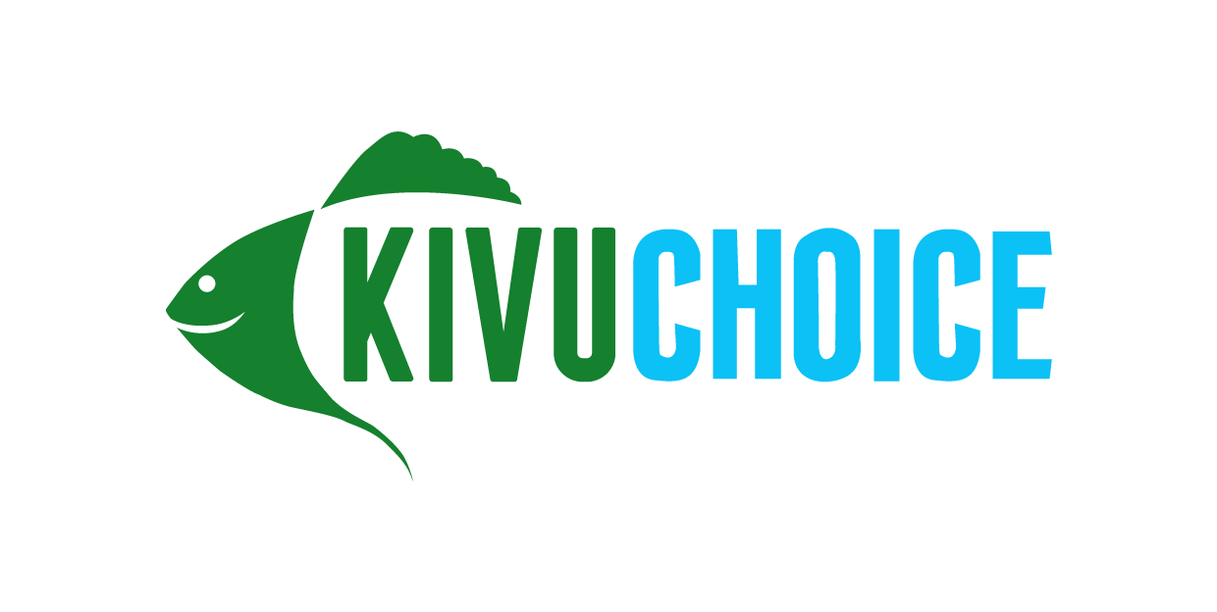

Job Title: Security Supervisor
Location: Kigembe
Compensation: 300K-400K NET
Start date: As soon as possible

About Kivu Choice:
Kivu Choice is the sister company to Victory Farms, the largest fish farm in East Africa, based in Kenya. We launched our Rwandan business in late 2021 and have since secured and commenced operations at two farm sites across Rwanda and will be launching our commercial operations in the coming weeks. Over the next 5 years our plan is to scale to become the largest and most sustainable protein producer in the country, producing and distributing over 50 million fish meals per year across Rwanda and DRC.
Description:
Kivu Choice is looking for an aspiring Security Supervisor to join our team and play an integral role in building the country’s premier aquaculture business. Should you be chosen, you will be trained from the ground up and work side by side with the Security Manager as we build out one of the largest aquaculture operations in Africa.

What we’re looking for:
- The successful applicant is likely to have already served in the military or as a police officer; they should have experience with prosecution and investigation.
- Ability to thrive while working collaboratively with colleagues, identifying, and solving problems independently in a fast-paced environment
- A successful candidate will possess a strong work ethic, ability to work in teams, intellectual curiosity, and ability to structure and solve problems
- Fluent in English and Kinyarwanda (Do not apply if you are not fluent in English!)

Duties:
- Ensure safety and protection of company property and stakeholders including but not limited to employees, customers, and suppliers always.
- Ensure that evacuation procedures and training is always adhered to by security personnel in appointed location
- Investigate and resolve issues in collaboration with other organs with the security mandate
- Work closely with local law enforcement institutions to gather information of any security risks to the farm.
- Monthly evaluation of guards and working schedules
- Report on gaps identified that might present theft of company properties
- Provide coaching and supervision of security guards provided by the contractual company
- Monitor the CCTV footage for all the traffic around the facilities
- Complete reports by recording observations, information, occurrences, and surveillance activities; interviewing witnesses; obtaining signatures
To apply, send your CV and the job title you’re applying for to recruiting@kivuchoice.com.

