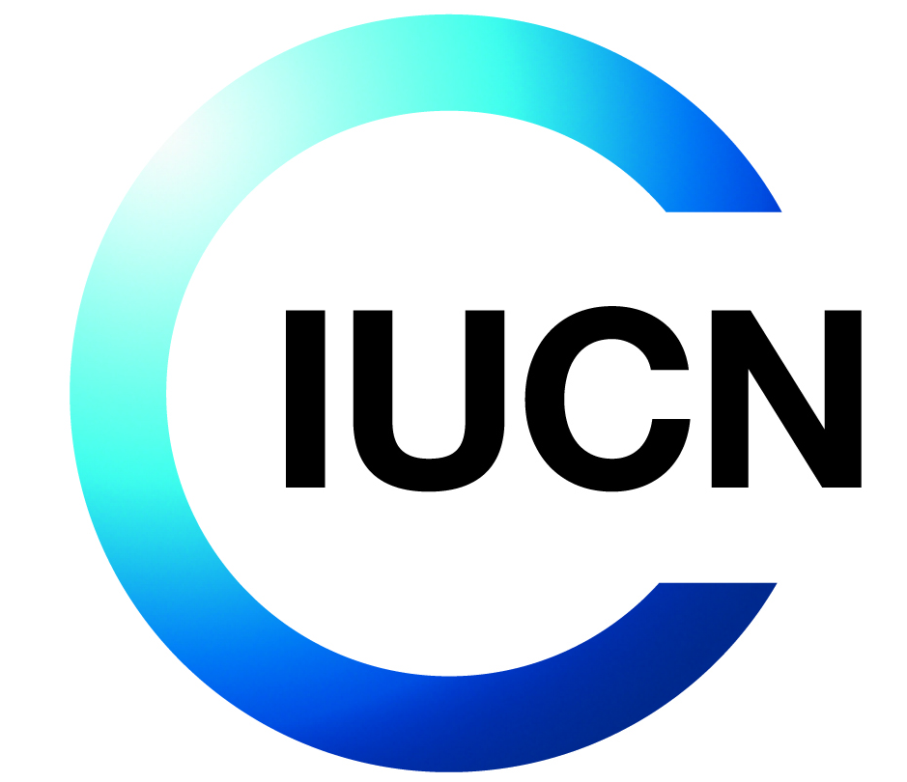
Terms of Reference for IUCN Consultancy

Title: AREECA Project End-Term Evaluation
Objective of the Consultancy
This consultancy has the following objective(s):
- Assessing the effectiveness and efficiency of project implementation, including examining the institutional arrangements, partnerships, risks, and project implementation.
- Evaluating both the biophysical and social-economic impact of the project and the contribution of its outputs to the overall purpose.
- Assessing the long-term sustainability of project activities.
- Identifying lessons learned and best practices (strategic processes and mechanisms are chosen to achieve the project objectives).
- Providing guidance and direction for maintaining the results/success achieved
Background
Project Reference: P02954
Donor reference: DN00292
About IUCN

IUCN is a membership Union uniquely composed of both government and civil society organisations. It provides public, private and non-governmental organisations with the knowledge and tools that enable human progress, economic development and nature conservation to take place together.

Created in 1948, IUCN is now the world’s largest and most diverse environmental network, harnessing the knowledge, resources and reach of more than 1,400 Member organisations and around 15,000 experts. It is a leading provider of conservation data, assessments and analysis. Its broad membership enables IUCN to fill the role of incubator and trusted repository of best practices, tools and international standards.

IUCN provides a neutral space in which diverse stakeholders including governments, NGOs, scientists, businesses, local communities, indigenous peoples organisations and others can work together to forge and implement solutions to environmental challenges and achieve sustainable development.

Working with many partners and supporters, IUCN implements a large and diverse portfolio of conservation projects worldwide. Combining the latest science with the traditional knowledge of local communities, these projects work to reverse habitat loss, restore ecosystems and improve people’s well-being.

www.iucn.org
https://twitter.com/IUCN/

About the Project
The Alliance for Restoration of Ecosystems in Africa (AREECA) is a multi-country initiative funded by the Federal Ministry of the Environment, Nature Conservation, and Nuclear Safety (BMU) of Germany. Implemented by a consortium comprising IUCN, FAO, WRI, WWF, AUDA-NEPAD, and the World Bank, the project operates across Rwanda, Kenya, Malawi, and Cameroon. AREECA seeks to enhance the economic, ecological, and climate benefits of large-scale Forest Landscape Restoration (FLR) by restoring 100,000 hectares of degraded land through sustainable land use options, while also catalyzing restoration efforts beyond the initial landscapes and countries.

In Rwanda, AREECA is working to restore 25,000 ha of degraded lands by initiating viable land-use options on 5,000 ha in Kirehe and Nyagatare Districts and establishing various enablers to catalyze restoration—a move that is expected to have a fivefold radiative effect in East Province and beyond. Now in its 5th year of implementation, the project is also designed to enhance local FLR capacity among stakeholders, provide policy advice on FLR, unblock large-scale restoration, and share FLR experiences and learned lessons. Some of the long-term benefits that are expected from this project include the reduction of GHG emissions, improved community resilience (particularly of poor subsistence farmers, women, and pastoralists) to the negative impacts of climate change, and reduced pressure on biodiversity and habitats.

To this end, the project, has yielded tremendous results, showing incredible impacts on people and landscapes. For example, the project has already put 5,114 ha of land under restoration where about 38% of tree species are native. The project has benefited over 48,000 people, including women and youths and continues to impact local communities through the grassroot bio-enterprises that set to run beyond 2025 through the Community Environment Conservation Scheme (CECS). AREECA has also supported a sub-national ROAM assessment and the development of a sub-national restoration strategy, informing restoration strategies in seven (7) districts in the Eastern province. The project has further developed various innovative approaches that are set to inform scaling-up efforts beyond AREECA. While AREECA has achieved notable successes, it has also navigated several significant challenges. These include the 2020-2021 global COVID-19 pandemic, which disrupted normal field operations, and the 2022 drought, which threatened the natural tree growing approach. Nevertheless, the project has yielded a myriad of lessons, success stories, and innovations that contribute to its unique character. These range from the development of tools and approaches that have ensured enhanced inclusivity and transparency, to effective national and local level stakeholder engagement that has fostered increased ownership of Forest Landscape Restoration (FLR) within the country.

Description of the Assignment
This study is commissioned by IUCN to assess the performance of AREECA project by looking at project achievements, challenges, impacts, and lessons learned that could be used for future reference and scaling FLR activities’ implementation, monitoring and evaluation.
- More specifically, the intended users and uses of this evaluation are:
- AREECA project partners in Rwanda that include Rwanda Forestry Authority and Districts for the purposes of assessing end-term performances.
- AREECA Project Steering Committee (PSC) which provided strategic direction of the project.
- IUCN Rwanda Country Office (RCO) Monitoring and Learning team, for the purpose of improving the monitoring and learning approach.
- IUCN Forest and Land Use programme for the purpose of gathering lessons to inform future project design and implementation of other projects.

- Objectives and evaluation questions
The end-term review will explore AREECA Project’s work and achievements with the aim of assessing progress and providing guidance on how the project maximized the potential for achieving the intended results and its legacy towards end of its timeframe (2021-2025). Through the assessment of the performance, achievements and lessons learnt to date, the evaluation will contribute to both learning and accountability.
Below are proposed evaluation criteria and questions of interest for the end-term evaluation, in line with the New IUCN evaluation Policy. However, potential consultants are welcome to provide suggestions on how to streamline and focus the evaluation further.
- Relevance:
  - To what extent did the work of the AREECA project addressed its objectives and the priority issues?
  - How relevant has been the AREECA project, its outputs, outcomes and impact achieved to Rwanda?
  - How important has the intervention been for the target Districts and to what extent has it addressed their needs and interests?
  - To what extent has the project adapted in terms of approaches and/or integrated recommendations formulated along the way to align its interventions and remain relevant to the local context?
  - How do beneficiaries perceive the relevance of the project and how have the activities implemented improved their lives?
- Coherence:
  - Who are the partners of the project and how strategic are they in terms of capacities and commitments?
  - Is there coherence and complementarity by the project with other actors for other local climate change interventions?
  - To what extent has the project complimented other on-going local-level initiatives (by stakeholders, donors, governments) on climate change adaptation or mitigation efforts?
  - How has the project contributed to achieving a stronger and more coherent integration of the shift to low-emission sustainable development pathways?
- Effectiveness:
  - To what extent has the project achieved its targets and objectives?
  - How effective were the project activity implementation modalities? How have the problems encountered been resolved?
  - Has the project achieved its set targets and expected objectives? What and how much progress has been made towards achieving the overall impacts such as adaptation beneficiaries and improved ecosystem services?
  - Was there value for money? Evaluate the funds flow and its effect to the project
  - Which elements of the project strategies and approaches were effective in contributing to the observed changes? Which elements were less effective? What could have worked better and how? Which elements could be scaled up?
  - What opportunities for collaboration have been utilized and how have these contributed to increased effectiveness? or otherwise?
- Efficiency:
  - To what extent are the project’s outputs in balance with the level of effort, time and resources spent?
  - Have spending and project delivery progressed according to the planned schedule?
  - Is the relationship between resources and results appropriate and justifiable?
  - Are there less costly ways of achieving the same outputs? What choices were, made in terms of collaboration and non-collaboration during program design? Why were, these choices made?
- Learning:
  - What can we learn from the way the AREECA project is designed and implemented?
  - What has and what hasn’t worked well so far and what needs to be improved or done differently?
  - Are there lessons or best practices that can be up scaled or replicated in similar environments?
- Sustainability:
  - Are the project interventions and benefits likely to continue after it ends?
  - What sustainability measures are in place?
  - What real difference has AREECA interventions made to the project’s target groups (male/female)? How has it changed their lives?
  - What exit strategy has the project adopted and how was it implemented?
- Impact Orientation:
  - How was the project oriented towards a positive impact on people and nature?
  - Facts/Indications of project positive impact on nature?
  - Facts/Indications of positive impacts on people’s lives and livelihoods?
- One Programme Approach:
  - Is the project leveraging the Union to achieve its objectives?
  - To what extent is AREECA project implemented in accordance with IUCN’s One Programme Approach?
  - To what extent has it engaged with other constituents of the Union to achieve, disseminate, strengthen, scale up or embed its outputs or outcomes?
- Gender, indigenous peoples, and youth:
  - To what extent has the AREECA project’s objectives and design promoted and advanced gender equality, gender responsiveness, and/or the needs and priorities of youth?
  - To what extent has the project monitored its progress with appropriately disaggregated monitoring data and with the participation of women and/or youth?
  - To what extent is the project compliant to environmental and social safeguards (ESS)?
- Science/policy/action interface:
  - How has the knowledge produced or disseminated by AREECA relevant?
  - Has it been effective in influencing policy or actions?

- Country ownership of projects and programmes:
  - How is the project contributing to other projects/programmes within the country? are there further commitments, e.g. more co-financing towards the project?
  - To what extent is the project aligned with national development plans, national plans of action on climate change, or sub-national policy as well as projects and priorities of national partners?
- Innovativeness in result areas:
  - To what extent may the project interventions lead to low-emission and climate-resilient development pathways?
- Replication and scalability:
  - Can the project activities be scaled up in other locations within the country or replicated in other countries?
- Unexpected results, both positive and negative
  - Has the project foreseen any unexpected results, both positive and negative?

Duration of the Assignment
October 01st – November 15th, 2025.
Deliverables and Activities
The consultant will provide the following deliverables and carry out the following activities:
Deliverable/Activity | Description | Deadline
Inception Report | Detailed methodology, annotated outline of guide, draft training plan | October 10th
Draft Report | Preliminary Findings | October 24th
Final Report | Final Revised Report including feedback provided on Draft Report | November 07th

Payment Schedule
The Timetable below summarises the chronological order of deliverables and indicates milestones at which IUCN will pay the Consultant.
Deliverable | Milestone payment
After submission and approval of Inception Report | 30%
After submission and approval of Draft Report | 40%
After submission and approval of Final Report | 30%

Skills and Experience
The consultant must have the following skills, education and experience as a minimum:
- Possess a Master’s Degree or Higher, in Forestry and Natural Resource Management, Socioeconomics, Environmental/Management/Studies, Climate change or related subjects.
- More than 5 years’ experience in project reviews and evaluation with demonstrated quantitative and qualitative data collection and analysis skills, with proven record of conducting mid-term, final/endline and impact evaluations.
- Proven experience in evaluating similar projects and having carried such assignment for IUCN or partner organizations would be an added advantage
- Experience of synthesising lessons and evidence of disseminating findings of project reviews/evaluations to donors, project partners, communities, and governments
- Fluency in English and Kinyarwanda
Supervision and coordination
The consultant will report to and work under the supervision of the Project Regional Coordinator (Regional Geospatial information and ROAM Officer) and in Country project Manager (GIS and Knowledge Management Officer).

