

INVITATION FOR BIDS
Re: Construction works of selling points and carrot washing stations in Musanze and Nyabihu Districts.
RFP/Call Number: RFP KTRW-001
Issuance Date: Wednesday September 16, 2025
Deadline for Questions: September 25, 2025
Deadline for Offers: September 30, 2025, 11:59pm
Description: Request for Proposal to Construct selling points and carrot washing stations in Musanze and Nyabihu districts.
Funded By: Kungahara Project funded by European Union through Rikolto SON.
Implemented By: Kilimo Trust Rwanda
Contact email: procurement@kilimotrust.org.

Appendixes.

1.BoQ Template & Drawings_ The specifications of the facilities to be constructed.

Lot_1_:1 Selling point -MUSANZE District /GATARAGA Sector
Square: 24.2mx7.7m
No | Designation of works | Unit | Quantity | Unit Price | Total (Fr)
1. PRELIMINARY WORKS
1.1 | The site installation including temporary store, Toilets, fence. | L.s
1.2 | Cleaning of the site after site installation includes leveling, removal of topsoil and any materials or objects not needed by the client and its transportation | L.s
1.3 | Setting out of the building by using efficient  equipment and materials | L.s
Sub Total 1.
II. SUBSTRUCTURE
2.1 | Excavation of thick foundation trenches to the level of good soil bearing capacity for foundation. | Cum
2.2 | Blinding concrete layer under stone masonry foundation mixed at the ratio of 250kg/m3 | Cum
2.3 | Rubble stones masonry for foundation, and jointed with cement mortar mixed with 300kg / CM. The remaining visible faces should be carefully mounted with exposed masonry including rejointing with cement mortar | Cum
2.4 | Top blinding concrete(chape) | Cum
Sub Total 2.
III. SUPER STRUCTURE
3.1 | Damp proof membrane | Lm
3.2 | Elevation in Masonry of burnt bricks jointed with  cement mortar mixed at 300kg/m3 | Cum
3.3 | Reinforced concrete for sub columns, and columns including scaffolding, formwork and fixtures, cutting, bending and laying of reinforcement; Concrete mixed at 350kg / CM | Cum
3.4 | Wall made in Welded Wire mesh | Sqm
3.5 | Reinforced concrete for continuous Lintels including formwork and supply, cutting, bending and installation of reinforcements, concrete mixed at: 350kg / CM | Cum
3.6 | Fencing made with masonry works and tubes
Sub Total 3.
IV. ROOF STRUCTURE
4.1 | Elevation with Hollow Steel Tube (80x40x1.5) | Pc
4.2 | Roof Structure with hollow steel tube (40x40x1.5) | Pc
4.3 | Roof Cover With metallic Sheet (Back Auto-portant BG 28) | Sqm
4.4 | Side Cover (1m heght) With metallic Sheet (Back Autoportant BG 28) | Sqm
V. SEILLING STAND (1X1X5.5m) AND FLOOR SLAB 5
5.1 | Floor Slab with Concrete | m²
5.2 | Gate door with lock System | PC
Sub Total 5.
VI. VERTICAL COATINGS
6.1 | Smooth Plastering with Cement mortar mixed at 350 kg/m3 on exterior and interior walls, and columns (in two layers) | Sqm
Sub Total 6.
VII. HORIZONTAL COATINGS
7.1 | Hardcore pavement in rubbles stones of 100mm in the interior of buildings including sidewalks | Cum
7.2 | Levelling ordinary concrete screed in apportioned cement 350kg / CM thickness of at least 80mm in internal of the building and on sidewalks | Sqm
7.3 | Supply and installation of 50cmx50cm Ceramic floor tiles including skirting inside the rooms | Sqm
7.4 | Polished concrete finish over and sides of counter | Sqm
Sub Total 7.
VIII. PAINTS
8.1 | Silk Viny paintings on walls, and columns in three layers | Sqm
8.2 | Enamel Paint for metallic surfaces | Sqm
Sub Total 8.
IX. Security lights
9.1 | Supply and installation of solar powered lights, fixtures and devices | LS
Sub Total 8.
X. SANITARIES
10.1 | Supply and installation of pipes for water supply, and drainage, toilets for men and women, wash hand basins, etc | L.s
10.2 | Supply and fix plastic rainwater harvesting tank of 10m³ with all accessories (support made of stone  masonry with cement mortar + tap). | Pcs
10.3 | Construction of compost pit with three components size of 1.5mx3m per each. | LS
Sub Total 10
GRAND TOTAL-

Layout of proposed selling point at Gataraga in Musanze District.
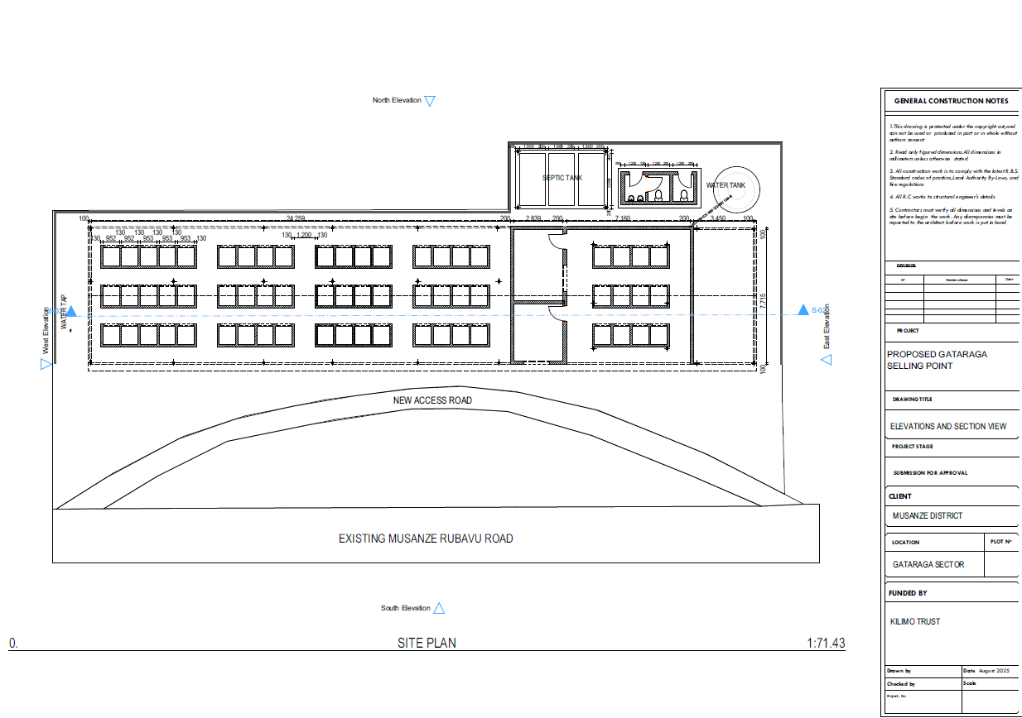
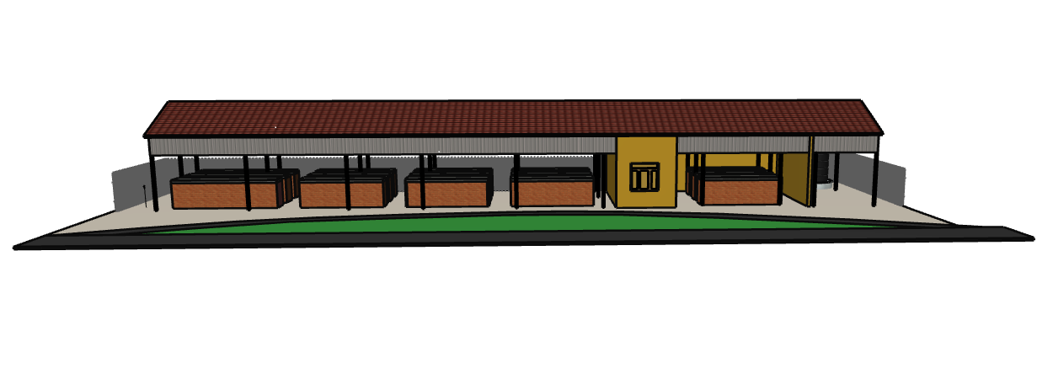

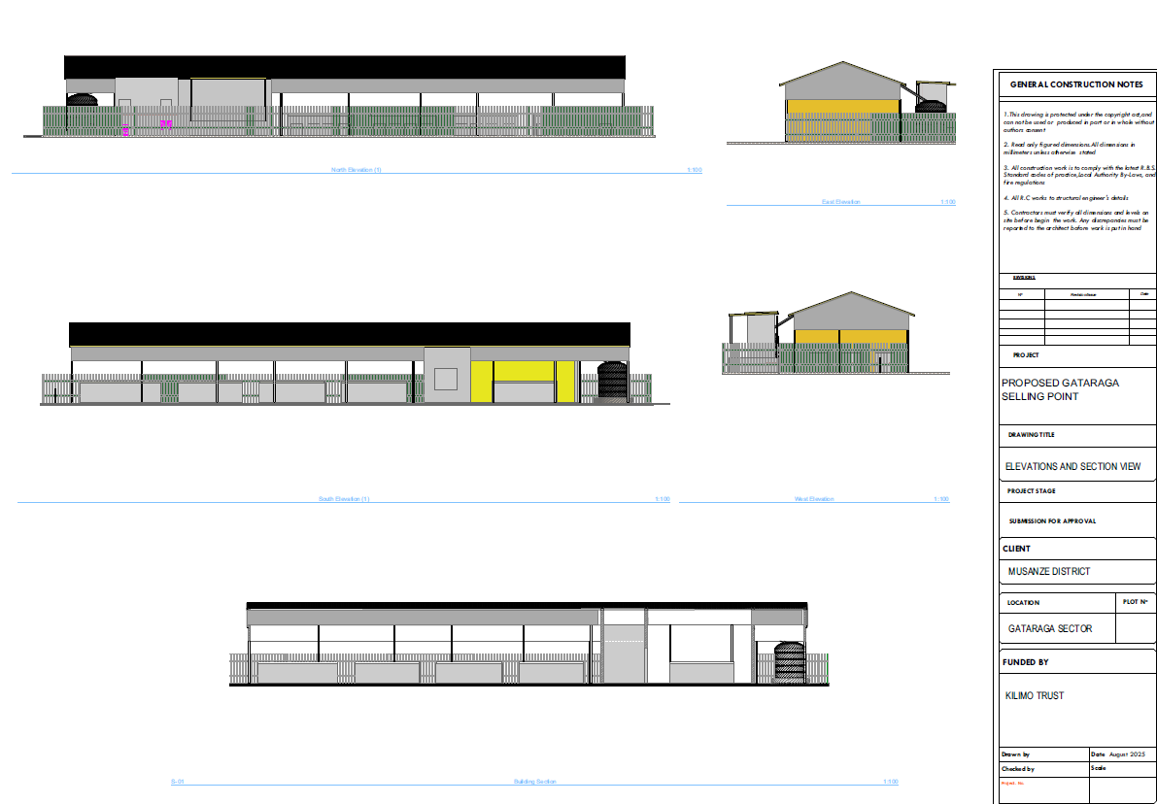

Lot_1_2:.Upgrading the Selling point -Nyabihu District / Mukamira Sector
Square: (13.2mx11.9m) for upgrading and (13.2mx8m) of newly constraction
No | Designation of works | Unit | Quantity | Unit Price | Total (Fr)
I. PRELIMINARY WORKS
1.1 | The site installation including temporary store, Toilets, fence. | L.s
2.2 | Cleaning of the site after site installation includes leveling, removal of topsoil and any materials or objects not needed by the client and its transportation | L.s
2.3 | Setting out of the building by using efficient  equipment and materials | L.s
Sub Total 1.
II. SUBSTRUCTURE
1.1 | Excavation of thick foundation trenches to the level of good soil bearing capacity for foundation. | Cum
2.2 | Blinding concrete layer under stone masonry foundation mixed at the ratio of 250kg/m3 | Cum
2.3 | Rubble stones masonry for foundation, and jointed with cement mortar mixed with 300kg / CM. The remaining visible faces should be carefully mounted with exposed masonry including rejointing with cement mortar | Cum
2.4 | Top blinding concrete(chape) | Cum
Sub Total 2.
III. SUPER STRUCTURE
3.1 | Damp proof membrane | Lm
3.2 | Elevation in Masonry of burnt bricks jointed with  cement mortar mixed at 300kg/m3 | Cum
3.3 | Reinforced concrete for sub columns, and columns including scaffolding, formwork and fixtures, cutting, bending and laying of reinforcement; Concrete mixed at 350kg / CM | Cum
3.4 | Wall made in Welded Wire mesh | Sqm
3.5 | Reinforced concrete for continuous Lintels including formwork and supply, cutting, bending and installation of reinforcements, concrete mixed at: 350kg / CM | Cum
3.6 | Fencing made with masonry works and tubes | LS
Sub Total 3.
IV. ROOF STRUCTURE
4.1 | Elevation with Hollow Steel Tube (80x40x1.5) | Pc
4.2 | Roof Structure with hollow steel tube (40x40x1.5) | Pc
4.3 | Roof Cover With metallic Sheet (Back Auto-portant BG 28) | Sqm
4.4 | Side Cover (1m heght) With metallic Sheet (Back Autoportant BG 28) | Sqm
V. SEILLING STAND (1X1X5.5m) AND FLOOR SLAB 5
5.1 | Floor Slab with Concrete | m²
5.2 | Gate door with lock System | PC
Sub Total 4.
VI. VERTICAL COATINGS
6.1 | Smooth Plastering with Cement mortar mixed at 350 kg/m3 on exterior and interior walls, and columns (in two layers) | Sqm
Sub Total 5.
VI. HORIZONTAL COATINGS
6.1 | Hardcore pavement in rubbles stones of 100mm in the interior of buildings including sidewalks | Cum
6.2 | Levelling ordinary concrete screed in apportioned cement 350kg / CM thickness of at least 80mm in internal of the building and on sidewalks | Sqm
6.3 | Supply and installation of 50cmx50cm Ceramic floor tiles including skirting inside the rooms | Sqm
6.4 | Polished concrete finish over and sides of counter | Sqm
Sub Total 6.
VII. PAINTS
7.1 | Silk Viny paintings on walls, and columns in three layers | Sqm
7.2 | Enamel Paint for metallic surfaces | Sqm
Sub Total 7.
VIII. Security lights
7.1 | Supply and installation of solar powered lights, fixtures and devices | LS
Sub Total 8.
IX. SANITARIES
8.1 | Supply and installation of pipes for water supply, and drainage, toilets for men and women, wash hand basins, etc | L.s
8.2 | Supply and fix plastic rainwater harvesting tank of 10m³ with all accessories (support made of stone  masonry with cement mortar + tap). | Pcs
8.3 | Upgrading of compost pit with three components size of 1.5mx3m per each. | LS
Sub Total 9
GRAND TOTAL-

Proposed upgraded layout
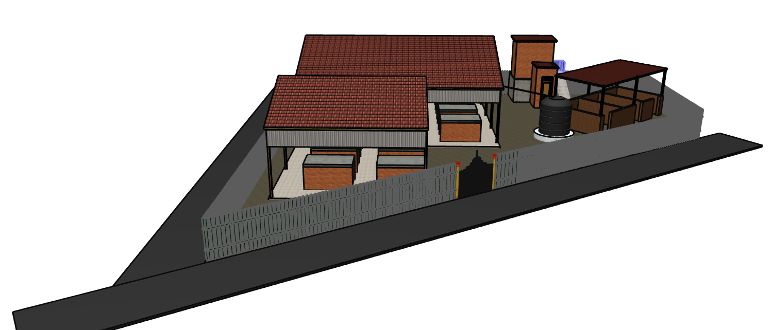
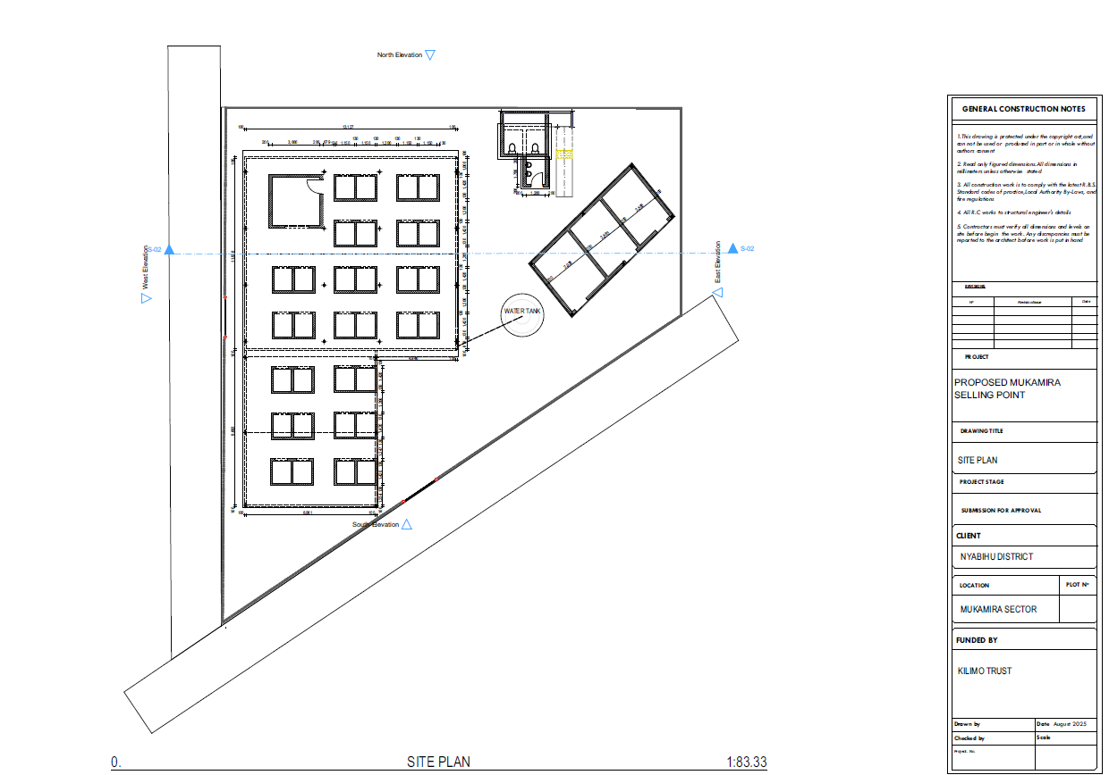

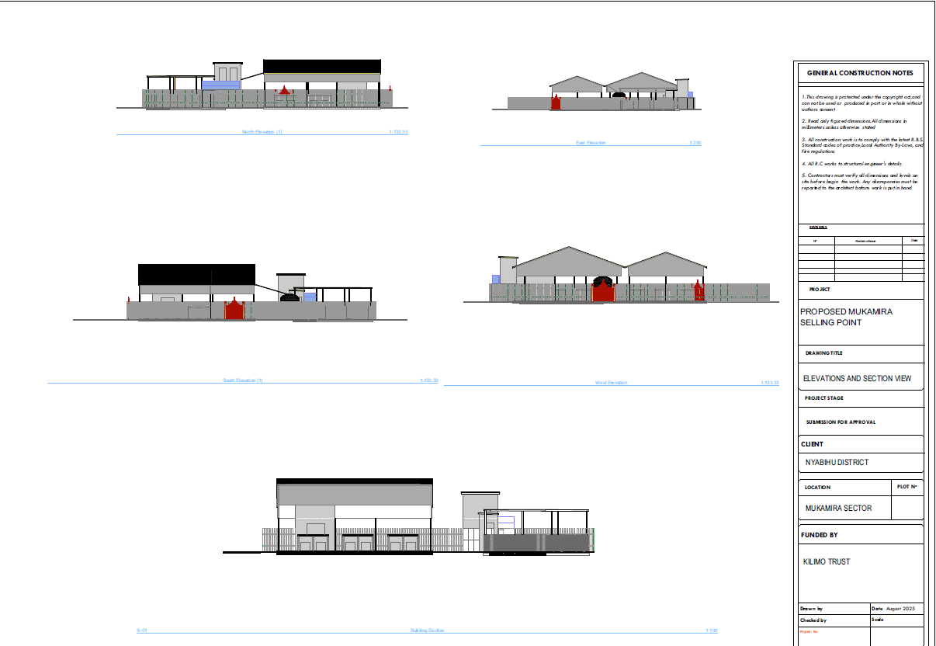

Lot_2_1: Construction of carrot washing station in Musanze District / Gataraga Sector sized of 16mx4m with three washing areas
No | Works description | Unit | Quantity | Unit Price | Total (Fr)
1 | PREPARATORY WORKS
1.1 | Site installation | LS
1.2 | Excavation to keep stable stand | LS
1.3 | Rock-filling prior to keep the agreed Floor slab slop(According to the site condition) | Sqm
 | S/Total 1
2 | ELEVATION WORKS
2.1 | Foundation With Stone masonry | m3
2.2 | Elevation Walls used Stone masonry | m3
2.3 | Plaster prior to receive Tiles | Sqm
2.4 | Ceramic Wall Tiles (20*30) | Sqm
2.5 | Supply and installation of solar powered lights, fixtures and devices | ls
2.6 | Supply and fix tank of 5m³ | LS
2.7 | Fencing made with masonry works and tubes | LS
 | S/Total 2
3 | Mini pump station and water supply with mini treatment plant
3.1 | Construction of Water Sucking area and mini soral Pump Support | LS
3.2 | Installation of waters supply system, Complete Kit Mini Soral Powered Pumping System | LS
3.3 | Installation of water supply Pipe and Fitting | LS
3.4 | Installation of water Filtration system before water sent back to the river | LS
 | S/Total 3
4 | Sanitaries
4.1 | Supply and installation of toilets for men and women, wash hand basins, etc | LS
4.2 | Construct of compost pit with two components size of 1.5mx3m per each. | LS
 | S/Total 3
5 | Paints
5.1 | Silk viny painting on walls and columns in three layers | ls
5.2 | Enamel paint for metallic surfaces | ls
GENERAL GRAND TOTAL

Proposed layout

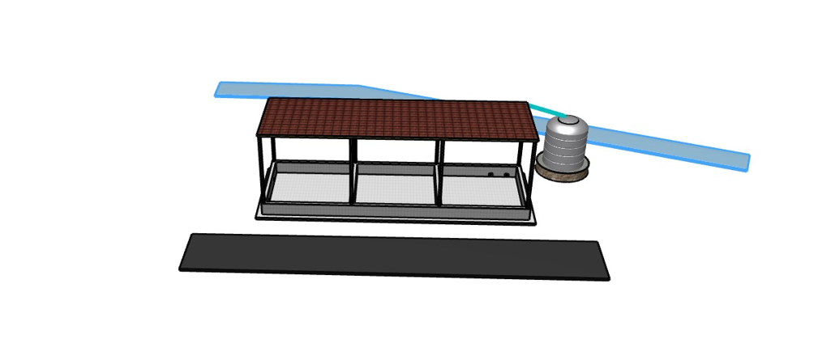

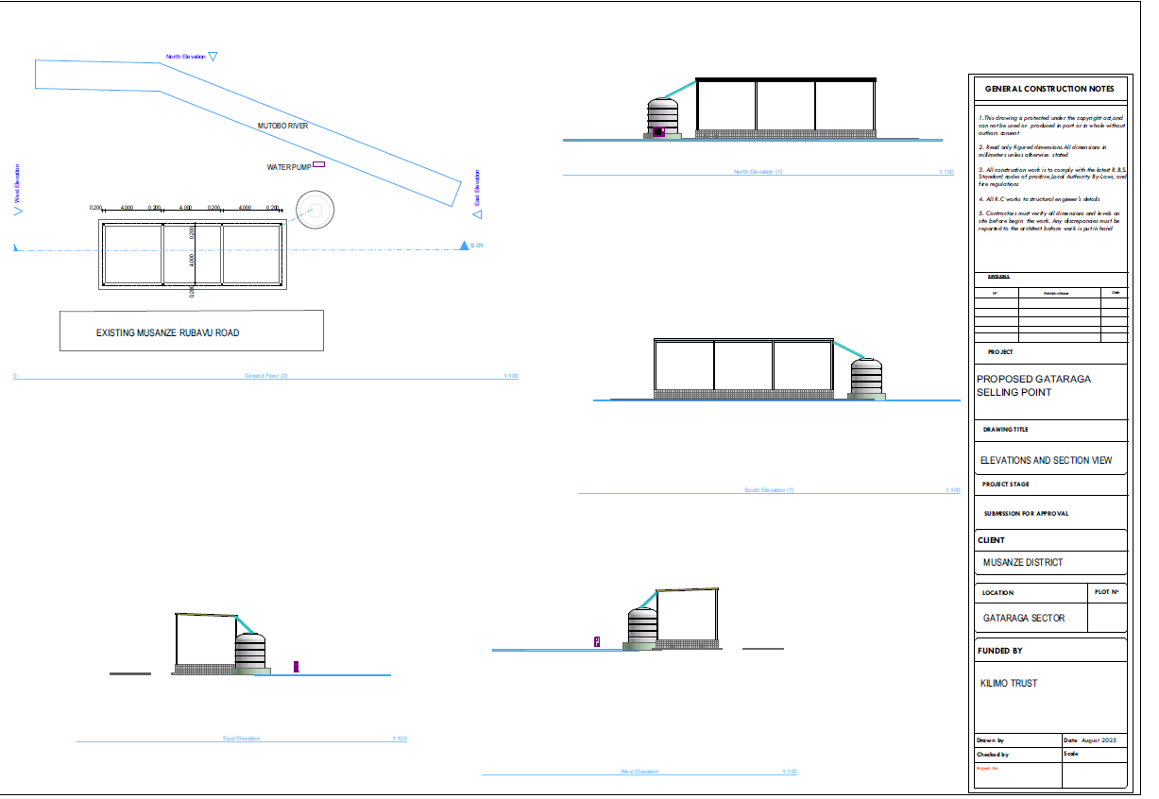
Lot_2_2: Upgrading carrot washing station in Nyabihu District / Jenda Sector
No | Works description | Unit | Quantity | Unit Price | Total (Fr)
1 | SUPPLY AND INSTALL OF WATER SUPLY MATERIALS
1.1 | Pumping water by using solar powered energy from water source to the site of carrot washing station (distance between is 630m) | LS
1.2 | Supply and fix accessories from the water source to the washing areas | LS
 | S/Total 1
2 | Upgrading the washing area
2.1 | Renewing the fences with tubes and wire mesh | m3
2.2 | Pavement of car parking | m3
2.3 | Installation of water Filtration system before water sent back to the river
2.4 | Supply and installation of solar powered lights, fixtures and devices | LS
 | S/Total 2
3 | Sanitaries
3.1 | Construction of toilet for men, women and hand washing area. | ls
3.2 | Construction of compost pit | ls
4 | Paints
4.1 | Silk viny painting on walls and columns in three layers | Ls
4.2 | Enamel paint for metallic surfaces | ls
 | S/Total 3
GENERAL GRAND TOTAL

2.Bid Evaluation Criteria

Technical Evaluation Criteria (PASSMARK 60 out of 70) | Maximum Points
Part A - Methodology & work plan (Maximum 40 Points)
The Subcontractor should prepare a technical proposal that details how this assignment shall
be executed. Rating criterial and weightings are as follows:
- General understanding of the assignment and clear methodology (Broken into stages with logical flow between phases and tasks) that demonstrates how the consultant will execute the assignment | 10
- Quality, completeness, and reasonableness of proposed work plan to achieve the objectives in the Statement of Work for proposed Lot | 10
- Health and Safety Plan | 10
- Quality Management Plan | 10
Part B - Team composition and previous experience (30 points)
A Project Manager with a minimum of a bachelor’s degree in civil engineering and 5 years’ experience in managing constructions of similar works, who will facilitate timely delivery of this scope of work | 10
A Foreman with a minimum of an ordinary Diploma in Civil engineering and 5 years’ experience in executing constructions of similar works | 5
Plan on community involvement in the construction. Indicate the skill set that will sourced from the host communities | 5
Similar works (selling Point, Carrot washing, pumping water by using solar powered energy) proven by good completion certificate and its contract. | 10
Part C - Equipment (10 points)
The contractor should also propose a set of equipment available for use in the execution of this project including:  - Hired or Owned Transportation truck  - Steel Bender  - Camera for taking progress pictures  - Laptop or desktop installed drafting software and Microsoft Office Suite  - Masonry Tool Kit with water level, tape measure, trowels, plumb line, square etc | 10
Technical Evaluation Scoring - Possible Total Score | 80
Cost Evaluation will be done for bidders with a minimum technical score of 60 out of 80
Cost Effectiveness Checks (20 Marks)
- Comparison with Internal Estimate (Bids 20% of more or under the Engineer’s Estimate will be  disqualified as non-responsive) | 10
- Comparison to Other Bidders Proposals | 5
- Cost realism  - Allocability; Check whether the cost is allocable to the BoQ items and is it to be used to solely advance the work being quoted for.  - Reasonableness: Evaluate if the proposed cost does not exceed that which would be incurred by a prudent person.  - Completeness: Check if the cost is accurate covering all BoQ items to completeness of a project/ activity. | 5
Maximum Score (Technical Score and Financial Score) | 100
Lots will be awarded as follows to the Technically Responsive Bidders
A Subcontractor can bid for one or two lots but shall not be awarded more than one Lot. Award will be made to the LOWEST COMBINATION of responsive bids for the two Lots.

